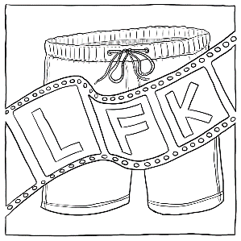 LFK 24-HOUR STAY-AT-HOME SHORT SHORTS FESTIVAL LEGAL WAIVER

Please read the following terms and conditions in connection with your written work or film entry material to the LFK 24-Hour Stay-at-Home Short Shorts Festival (LFK24SHSSF). If acceptable, please complete the form below.

1. As the author/director/producer/cinematographer of the screenplay, stageplay, short story, teleplay, TV, film score, radio play, &/or film (material), & etc. I/we have submitted to the LFK 24-Hour Stay-at-Home Short Shorts Festival (LFK24SHSSF). I/we warrant as sole and exclusive owner(s) of all legal right and title thereto have absolute authority to submit the enclosed material to LFK24SHSSF.

2. I/we will indemnify and hold harmless LFK24SHSSF, its judges, sponsors and partners, individually and collectively, from and against all claims, demands, losses, damages, costs, liabilities and expenses including legal expenses arising out of or in connection with any and all claims, or third party claims based on material submitted to LFK24SHSSF.

3. LFK24SHSSF finalists, winners & filmmakers of selected films will permit LFK24SHSSF to use title of the work submitted and the logline, their name, contact information and/or likeness & publicity stills, brief film clips, trailers, and/or film footage in pre & post-competition publicity & promotional efforts.

4. By agreeing this release form I/we understand and agree to all the terms and conditions of submission of materials to this competition, which are listed in this release form, and in the guidelines and entry form.

5. I/we have read, understand and agree to, and will abide by, all of the guidelines, rules & regulations posted for the LFK24SHSSF.

